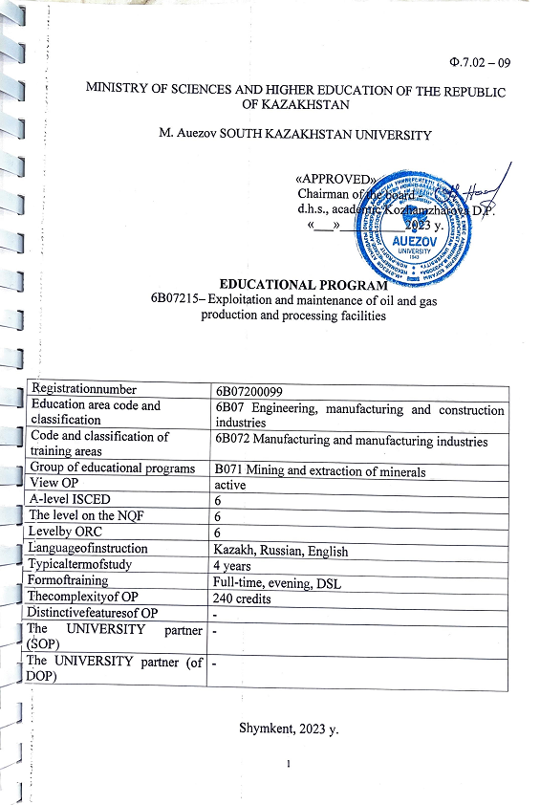
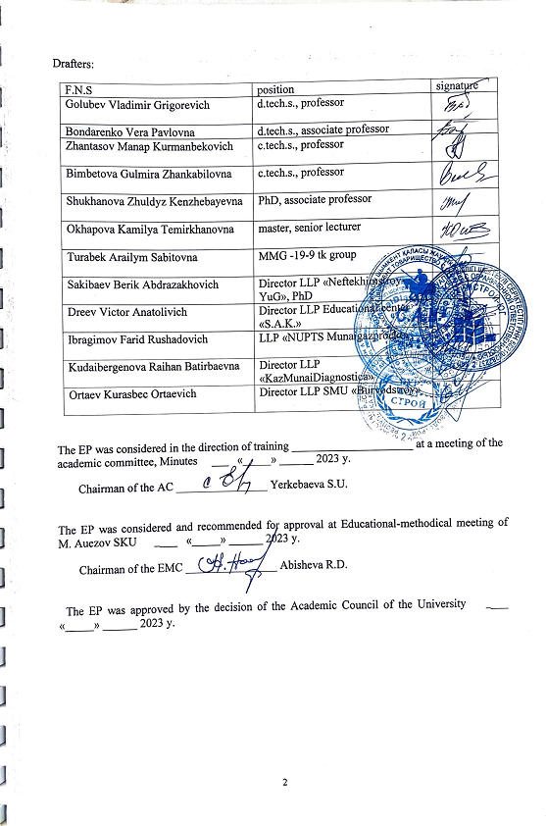
CONTENT

1 | Сoncept ЕР | 4
2 | Learningoutcomesfor EP | 6
3 | Competences of the graduate of EP | 9
4 | Matrix of the influence of disciplines on the formation of learning outcomes and information about labor intensity | 11
5 | Summary table reflecting the volume of loans disbursed by modules of the educational program | 67
6 | Learning strategies and methods, monitoring and evaluation | 68
7 | Educational and resource support of the plo | 69
 | Approval sheet | 70
 | Appendix 1. Review from the employer | 71
 | Appendix 2. Expertopinion | 81

- PROGRAM CONCEPT

Mission of the University  University Values | Generating of new competencies, training a leader who translates research thinking and culture

Openness–open to change, innovation and cooperation.
- Creativity – generates ideas, develops them and turns them into values.
- Academic freedom – free to choose, develop and act.
• Partnership – creates trust and support in a relationship where everyone wins.
• Social responsibility – ready to fulfill obligations, make decisions and be responsible for their results.
Graduate Model | • Deep subject knowledge, its application and constant expansion in professional activity.  • Information and digital literacy and mobility in a rapidly changing environment.  • Research skills, creativity and emotional intelligence.  • Entrepreneurship, independence and responsibility for their activities and well-being.  • Global and national citizenship, tolerance for cultures and languages.
Uniqueness  of the EP | • Training of specialists with conceptual knowledge in the field of engineering and technology, who are able to independently set and solve problems, using adequate methods and means to achieve them, to carry out professional, scientific and entrepreneurial activities.
Academic Integrity and Ethics Policy | The University has taken measures to maintain academic integrity and academic freedom, protection from any kind of intolerance and discrimination:  - Rules of academic integrity (Minutes of the Academic Council No. 3 dated 30.10.2018);  - Anti-corruption Standard (order №373 373 n/a dated 27.12.2019).  - Code of Ethics (Minutes of the Academic Council №8 от 31.01.2020).
Regulatory framework for the development of EP | 1. Law of the Republic of Kazakhstan "On Education";  2. Standard rules of activity of educational organizations implementing educational programs of higher and (or) postgraduate education, approved by Order of the Ministry of Education and Science of the Republic of Kazakhstan dated October 30, 2018 No. 595 with amendments and additions dated December 29, 2021 No. 614  3. State obligatory standards of higher and postgraduate education, approved by order of the Ministry of Education and Science of the Republic of Kazakhstan dated July 20.2022 No. 2;  4. Rules for organizing the educational process on credit technology of education, approved by order of the Ministry of Education and Science of the Republic of Kazakhstan dated April 20, 2011 No. 152;  5. Qualification directory of positions of managers, specialists and other employees, approved by order of the Minister of Labor and Social Protection of the Population of the Republic of Kazakhstan dated December 30, 2020 No. 553.  6. Guidelines for the use of ECTS.  7. Guidelines for the development of educational programs for higher and postgraduate education, Appendix 1 to the order of the Director of the Center for the Bologna Process and Academic Mobility No. 45 o/d dated June 30, 2021  Industry qualifications framework for oil and gas refining and oil chemical industries (Protocol №.2 of December 27, 2016); Industry Qualifications Framework "Exploration and Production of Natural Gas" (Protocol of the Industry Commissions on Social Partnership and Regulation of Social and Labor Relations of the Oil and Gas Industry "№ 2 – 2019 dated June 28, 2019); Professional standards: "Putevoy under the heat of the Nephthys" (224 from 26.12.2022, Annex apostille 2), "cargo and transport operations on oil" (apostille 224 of 26.12.2022, Annex apostille 3), "Gas Transport Management" (№ 266 dated 27.12.2019, Appendix № 23). "Operation and repair of the compressor station" (№ 266 dated 27.12.2019, Appendix № 24). "Operation and repair of the distribution gas pipeline" (№ 266 dated 27.12.2019, Appendix № 26), "Operation and repair of technological equipment" (№ 266 dated 27.12.2019, Appendix № 27), "Operation of trunk pipelines" (№ 224 dated 06.12.2022, Appendix № 27), "Maintenance of auxiliary systems, instrumentation and automation" (№ 224 of 06.12.2022, Appendix № 20), "Well research" (№ 224 dated 06.12.2022, Appendix № 14), "Preparation and pumping of oil" (№ 266 dated 27.12.2019, Appendix № 46), "Maintenance of reservoir pressure" (№ 266 dated 27.12.2019, Appendix № 47), "Technology of oil and gas production" (№ 266 dated 27.12.2019, Appendix № 51), "Management of oil and gas production" (№ 224 dated 06.12.2022, Appendix №15), "Operation of oil and gas wells" (№224 dated 06.12.2022, Appendix № 5)
Organization of the educational process | - Implementation of the principles of the Bologna Process  - Student-centered learning  - Availability  - Инклюзивность
Quality assurance of EP | - Internal quality assurance system  - Involvement of stakeholders in the development of the OP and its evaluation  - Systematic monitoring  • Updating content (updating)
Requirements for applicants | Established in accordance with the Model Rules for Admission to Education in Educational Organizations Implementing Educational Programs of Higher and Postgraduate Education Order of the Ministry of Education and Science of the Republic of Kazakhstan No. 600 of 10/31/2018
Conditions for the implementation of the EP for persons with disabilities and the GEP | Tactile PVC tiles, specially equipped toilets, a mnemonic diagram, and bars in shower rooms have been installed for students with SEN and LSI in educational buildings and student dormitories. Special parking spaces have been created. Crawler lift installed. There are desks for MGN, signs indicating the direction of movement, ramps. In the educational buildings (main building, building No. 8) there are 2 rooms with six working places adapted for users with disorders of the musculoskeletal system (ODA). For visually impaired users, the SARA™ CE Machine (2 pcs.) is available for scanning and reading books. The library website is adapted for the visually impaired. There is a special NVDA audio program with a service. The JIC website http://lib.ukgu.kz/ is open 24/7.  An individual differentiated approach is provided for all types of classes and in the organization of the educational process,

- PASSPORT DESCRIPTION
Purpose of the OP | - training of a highly qualified, competent specialist in demand in the labor market, who has practical skills in servicing oil and gas production facilities.
OP tasks | - formation of socially responsible behavior in society, understanding the importance of professional ethical standards and following these standards;  - providing basic bachelor's training that allows them to continue their studies throughout their lives, successfully adapt to changing conditions throughout their professional career;  - providing conditions for acquiring a high general intellectual level of development, mastering competent and developed speech, culture of thinking and skills of scientific organization of work in the oil and gas sector;  - creation of conditions for intellectual, physical, spiritual, aesthetic development to ensure the possibility of their employment in the specialty or continuing education at subsequent levels of study
Harmonization of OP | - 6th level of the National Qualifications Framework of the Republic of Kazakhstan;  - Dublin descriptors of the 6th level of qualification;  - 1 cycle of the Qualification Framework of the European Higher Education Area (Qualifications System of the European Higher Education Area);  - Level 6 of the European Qualification Framework for Lifelong Learning (The European Qualification Framework for Life long Learning).
Communication of the EP with the professional sphere | Professional standards: “Oil track heating” (No. 224 dated December 26, 2022, Appendix No. 2), “Commodity and transportation operations for oil” (No. 224 dated December 26, 2022, Appendix No. 3), “Gas transport management "(No. 266 of December 27, 2019, Appendix No. 23). "Operation and repair of the compressor station" (No. 266 of December 27, 2019, Appendix No. 24). "Operation and repair of the distribution gas pipeline" (No. 266 of December 27, 2019, Appendix No. 26), "Operation and repair of technological equipment" (No. 266 of December 27, 2019, Appendix No. 27), "Operation of main labor pipelines" ( No. 224 of 06.12.2022, Appendix No. 27), “Maintenance of auxiliary systems, instrumentation and automation” (No. 224 of 06.12.2022, Appendix No. 20), “Well survey” (No. 224 of 06.12. 2022, Appendix No. 14), “Oil treatment and pumping” (No. 266 of December 27, 2019, Appendix No. 46), “Reservoir pressure maintenance” (No. 266 of December 27, 2019, Appendix No. 47), "Oil and gas production technology" (No. 266 of December 27, 2019, Appendix No. 51), "Oil and gas production management" (No. 224 of December 6, 2022, Appendix No. 15), "Oil and gas wells operation" (No. 224 dated 12/06/2022, Appendix No. 5)
Name of the degree awarded | After the successful completion of this EP, the graduate is awarded the degree: "Bachelor of Engineering and Technology in Educational 6B07215 -Operation and Maintenance of Oil and Gas Production Facilities""
List of qualifications and positions | They can hold positions in organizations for the operation and maintenance of facilities without presenting requirements for work experience in accordance with the qualification requirements of the Qualification Directory for the positions of managers, specialists and other employees, approved by order of the Minister of Labor and Social Protection of the Republic of Kazakhstan dated December 30, 2020 No. 553.:  - process engineer of oil heating furnaces;  - engineer for the operation and maintenance of gas equipment;  - engineer for the preparation and transportation of oil and gas;  - TGVSiK engineer;  - senior dispatcher of main pipelines;  - Engineer of the oil acceptance point;  - oil metering engineer;  - dispatcher of main pipelines;  - engineer for the operation of main pipelines;  - Engineer of an oil (gas) pumping station;  - engineer for technical diagnostics;  - railway overpass operation engineer (oil and oil products);  - engineer for the supervision of boilers and steam and hot water pipelines;  - geologist for the development of oil and gas fields;  - Head of engineering and technical service (oil);  - Operations Engineer (oil);  - Engineer for oil and gas production;  - well integrity engineer.
Sphere of professional activity | The sphere of professional activity is the technical field of oil, gas and condensate production
Objects of professional activity | The objects of professional activity of graduates are enterprises of the oil and gas complex, regardless of their form of ownership, oil, gas and gas condensate fields on land and at sea
Subjects of professional activity | Technological processes for the development and operation of oil and gas fields on land and at sea.
Types of professional activity | • organizational and technological,  • production and management,  • calculation and design.  • service and operational divisions of the oil and gas industry,  • bodies of the Ministry of Emergency Situations, Gosgortekhnadzor,  • environmental and regulatory organizations, consulting organizations.
Learning outcomes | LO1 Communicate freely in a professional environment and society in Kazakh, Russian and English to solve the problems of interpersonal and intercultural interaction, taking into account the principles of academic writing and a culture of academic honesty.  LO2 Demonstrate general educational, natural science, mathematical, socio-economic and engineering knowledge in professional activities, mastery of methods of mathematical data processing, methods of scientific and experimental research, knowledge of regulatory documents and elements of economic analysis.  LO3 Possess the skills of information and communication, digital technologies and processing of experimental data, generalization, analysis and perception of information using special software systems for interpreting borehole geophysical data and exploitation technological equipment.  LO4 Ensure control over the exploitation of technological facilities and structural units for the extraction and processing of hydrocarbon raw materials, taking into account compliance with the requirements of labor protection, industrial safety and environmental safety of production.  LO5 Conduct an analysis of violations of the rules for the technical exploitation of equipment and develop measures to improve the reliability of equipment for the production, preparation, storage and processing of oil and gas.  LO6 Assess the quality of installation, repair work and corrosion protection of process equipment and test process equipment for the production, treatment and processing of oil and gas.  LO7 Own the technological processes of production, exploitation and processing of oil and gas in accordance with the technological regulations and the use of modern technical means for measuring the main parameters of the properties of raw materials and products.  LO8 Develop organizational and technical measures aimed at fulfilling tasks for the extraction and processing of oil and gas, introduce methods of scientific research, innovation management and development work  LO9 To control the physical and chemical parameters of oil and gas at the stages of production, preparation and processing in order to achieve the required quality of manufactured components and commercial products of oil and gas processing facilities.  LO10 Participate in activities to improve technological processes, improve the quality of products and analyze the results of production activities of installations.  LO11 Ensure the introduction of progressive economically justified resource, energy-saving technological processes and modes of production of manufactured products, aimed at increasing the level of technological preparation and technical re-equipment and modernizing production.  LO12 Work effectively individually and as part of a team, demonstrating self-education and healthy lifestyle skills

3. COMPETENCIES OF A GRADUATE OF THE OP

GENERAL COMPETENCIES (SOFT SKILLS). Behavioral skills and personal qualities
GC 1. Competence in managing one's literacy | GC1.1. The ability to self-study, self-develop and constantly uChDate their knowledge within the chosen trajectory and in an interdisciplinary environment.  GC 1.2. Ability to express and understand concepts, thoughts, feelings, facts and opinions in the oil and gas field in written and oral forms (listening, speaking, reading and writing).  GC 1.3. The ability to mobility in the modern world and critical thinking.
GC2. Language competence | GC 2.1. Ability to build communication programs in the state, Russian and foreign languages.  GC 2.2. The ability to interpersonal social and professional communication in the context of intercultural communication.
GC3. Mathematical competence and competence in the field of science | GC 3.1. The ability and willingness to apply the educational potential, experience and personal qualities acquired during the study of mathematical, natural science, technical disciplines at the university to solve professional problems.
GC 4. Digital competence, technological literacy | GC 4.1. The ability to demonstrate and develop information literacy through the mastery and use of modern information and communication technologies in all areas of their lives and professional activities.  GC 4.2. The ability to use various types of information and communication technologies: Internet resources, cloud and mobile services for the search, storage, protection and dissemination of information.
GC 5. Personal, social and educational competencies | GC 5.1. Ability to observe social and ethical values, tolerance to traditions, customs, norms and focus on them in their professional activities;  GC 5.2. The ability to socio-cultural development based on the manifestation of citizenship and morality.  GC 5.3. Ability to comply with the fundamentals of the legal system and legislation of Kazakhstan, trends in social development of society;  GC 5.4. The ability to adequately navigate in various social situations; to find compromises, to correlate their opinion with the opinion of the team;  GC 5.5. The ability to build a personal educational trajectory throughout life for self-development, career growth and professional success.  GC 5.6. The ability to successfully interact in a variety of socio-cultural contexts during study, at work, at home and at leisure.
GC 6. Entrepreneurial competence | GC 6.1. The ability to be creative and enterprising in different environments.  GC 6.2. Ability to work in the mode of uncertainty and rapid change of task conditions, creativity and an active lifestyle;  GC 6.3. Ability to manage projects to achieve professional goals, manage staff, demonstrate entrepreneurial skills.
GC 7. Cultural awareness and self-expression | GC 7.1. The ability to show ideological, civic and moral positions.  GC 7.2. The ability to be tolerant of the traditions and culture of other peoples of the world, to possess high spiritual qualities.
GC 8. Additional competencies | GC 8.1. The ability to show personal competencies of organization, initiative and responsibility, the desire to improve the professional level, the choice of methods of physical education and health promotion,  GC 8.2. The ability to make professional decisions in conditions of uncertainty and risk.
PROFESSIONAL COMPETENCIES (HARDSKILLS).
Theoretical knowledge and practical skills specific to this field | PC1. The ability to draw up standard design, technological and working documents in accordance with the established requirements.
 | PC2. The ability to implement and adjust technological processes during production, as well as preparation of wells for operation, methods of influencing the bottom-hole zone of the well and the study of wells on land and at sea.
 | PC3. The ability to collect data for the performance of oil, gas and condensate production, as well as the collection and preparation of well products.
 | PК4. The ability to operate technological equipment used in the production of oil, gas and condensate, as well as the collection and preparation of well products.
 | PC 5. The ability to assess risks and determine measures to ensure the safety of technological processes in oil and gas production.

3.1 Matrix of correlation of the results of training in the OP as a whole with the formed competencies of the modules

 | Р1 | Р2 | Р3 | Р4 | Р5 | Р6 | Р7 | Р8 | Р9 | Р10 | Р11 | Р12
КК1 | +
КК2 | +
КК3 |  | + |  |  |  |  |  | + | +
КК4 |  | + | +
КК5 | + | + | + |  |  |  |  |  |  |  |  | +
КК6 |  | + |  |  |  |  |  |  |  |  | + | +
КК7 | + |  |  |  |  |  |  |  |  |  |  | +
КК8 |  |  |  | + | + |  |  |  |  |  | +
PК1 |  | + | + | + | + | + | + | + | + | + | + | +
PК2 |  |  |  | + | + | + | + | + | + | + | + | +
PК3 |  |  | + | + | + | + | + | + | + | + | + | +
PК4 |  |  |  | + | + | + | + | + | + | + | + | +
PК5 |  | + |  | + | + | + | + | + | + | + | + | +

4. MATRIX OF THE INFLUENCE OF DISCIPLINES ON THE FORMATION OF LEARNING OUTCOMES AND INFORMATION ABOUT LABOR INTENSITY
№ | The name of the module | CYCLE | ВК/EC | Component name | Brief description of the discipline | Number of credits | Generated learning outcomes (codes)
 |  |  |  |  |  |  | LО1 | LО2 | LО3 | LО4 | LО5 | LО6 | LО7 | LО8 | LО9 | LО10 | LО11 |  | LО 12
1 | Fundumentals of the Public Sciences | GED | ОC | History of Kazakhstan | Purpose:The purpose of the discipline isformation of an objective idea of the history of Kazakhstan based on a deep understanding and scientific analysis of the main stages, patterns and originality of the historical development of Kazakhstan.  Contents: Ancient people and the formation of nomadic civilization. Turkic civilization and the great steppe. Kazakh Khanate. Kazakhstan in the era of modern times. Kazakhstan as part of the Soviet administrative-command system. Declaration of Independence of Kazakhstan.  State system, socio-political development, foreign policy and international relations of the Republic of Kazakhstan. Methods and techniques of historical description for the analysis of the causes and consequences of events in the history of Kazakhstan. | 5 | Ѵ | Ѵ
2 |  | GED | ОC | Philosophy | Purpose: The formation of a holistic idea among students about philosophy as a special form of knowledge of the world, about its main sections, problems and methods of studying them in the context of future professional activity. And also the formation of philosophical reflection, introspection and moral self-regulation among students.  Contents: Emergence of a culture of thinking. Subject and method of philosophy. Fundamentals of philosophical understanding of the world: questions of consciousness, spirit and language. Being. Ontology and metaphysics. Cognition and creativity. Education, science, technology and technology. Human philosophy and the world of values. Ethics. Philosophy of values. The subject of aesthetics as a field of philosophical knowledge. Philosophy of freedom. Philosophy of art. Society and culture. Philosophy of history. Philosophy of religion. "Mangіlіk El" and "Modernization of Public Consciousness" are a new Kazakhstan philosophy | 5 | Ѵ | Ѵ
3 | Socio-Political knowledges | GED | ОC | Sociology and Political Science | Purpose:The goal of forming knowledge about social and political activities, explaining social and political processes and phenomena.  Contents:Consideration of the system of socio-ethical values ​​of the society. Ways to use social, political, cultural, psychological institutions, features of youth policy in the modernization of Kazakhstani society and solve conflict situations in society and professional environment based on them.  To study the methods of analysis and interpretation of political institutions and processes, ideas about politics, power, state and civil society, to understand and use the methods and methods of sociological, comparative analysis, to understand the meaning and content of the political situation in the modern world. Analysis and classification of the main political institutions. | 4 | Ѵ
4 |  | GED | ОC | Cultural studies and psychology | Purpose: the formation of scientific knowledge of history, modern trends, current problems and methods for the development of culture and psychology, the skills of a systematic analysis of psychological phenomena.  Contents: Morphology, language, semiotics, anatomy of culture. Culture of nomads, proto-Turks, Turks. Medieval culture of Central Asia. Kazakh culture at the turn of the XVIII - XIX centuries, XX century. Cultural policy of Kazakhstan. State Program "Cultural Heritage". National consciousness, motivation. Emotions, intellect. The will of man, the psychology of self-regulation. Individual typological features. Values, interests, norms are the spiritual basis. The meaning of life, professional self-determination, health. Communication of the individual and groups. Socio-psychological conflict. Models of behavior in conflict. | 4 | Ѵ | Ѵ
5 | Socio-ethnic Development | GED | HsC | Ecosystem and law | Рurpose: Formation of integrated knowledge in the field of economics, law, anti-corruption culture, ecology and life safety, entrepreneurship, scientific research methods.  Content: Fundamentals of safe human-nature interaction, ecosystem and biosphere productivity. The entrepreneurial activity of society in conditions of limited resources, increasing the competitiveness of business and the national economy. Regulation of relations in the field of ecology and human life safety. Knowledge and compliance of Kazakhstan’s law, obligations and guarantees of subjects, state regulation of public relations to ensure social progress. Application of scientific research methods. | 5 |  |  |  | Ѵ
6 |  | GED | HsC | Actual problems and modernization of public consciousness | Рurpose: of the discipline is the restoration of spirituality, deformed during the periods of tsarist and Soviet reality, the formation of a creative personality based on the modernization of the public consciousness of young people.  Content: Spiritual modernization: origin and background. Modern national identity. Pragmatism and competitiveness. National identity and national code. Experience and prospects of evolutionary development. The triumph of knowledge and openness of consciousness. Alphabet Reform: Experience and Priorities. Fatherland is the basis of the state. Education through nationwide sacred places and history. Modern Kazakh culture is the cornerstone of spiritual revival. New humanitarian education and the future national intelligentsia. Abai Kunanbaev and Kazakh society. | 5 | Ѵ
7 |  | BD | EC | Mukhtar Study | Purpose: Formation of a historical, literary idea of M. Auezov's work in the context of literary history, patriotism and cultural and spiritual position. Development of artistic thinking, skills of independent research activity.  Сontent: The life and creative path of M. Auezov Semipalatinsk, Tashkent, St. Petersburg periods. M. Auezov's activity in the magazines «Sholpan», «Abai». M. Auezov's journalism. An artistic review of the short stories "Korgansyzdyn kuni", "Kyr suretteri", "Okagan azamat", "Kokserek", the play Enlik-Kebek and the stories "Kili Zaman", "Karash-Karash" okigasy", the monograph "Abai Kunanbayev", the epic novel "Abai Zholy". | 3 | Ѵ
8 |  | BD | EC | Abai Study | Purpose: based on the creativity of A.Kunanbayev, the preservation of the «national code» and in the project «Kazakhtanu»  Contents: historical overview of the history of Kazakhstan and Kazakh literature of the XIX-XX centuries. Studies of Abai's legacy of the XX-XXI century. Chronology of Abai's creativity. Abai is a great poet, ethnographer, founder of Kazakh written literature. Abai is the compiler of the code of laws «The Position of Karamola», social significance. Abai is a thinker, religious scholar, philosopher. The role of Abai in education and science, the concept of a «Holistic person». «Words of Edification»by Abai, an epic novel by M.Auyezova «The Way of Abai» . K. Tokayev «Abai and Kazakhstan in the XXI century», role, significance. | 3 | Ѵ
7 |  | BD | EC | Service to Society | Purpose: the formation of socially significant skills and competencies in students based on the assimilation of academic programs, carrying out socially useful activities related to the disciplines studied at the university.  Content. The concept and meaning of Service learning, the history of the formation and development of the concept of Service Learning. Key components of Service Learning, socially useful activities in the children's and youth environment, organization of volunteer movement in the world and Kazakhstan practice, profile orientation of Service Learning. International practice of learning through socially useful activities. General principles and methodology for the development of social projects. Methods of analysis of implemented social projects. | 3 | Ѵ |  |  |  |  |  |  |  |  |  |  | Ѵ
 |  | BD | EC | Foundations of Anticorruption Culture | Purpose: formation of an anti-corruption worldview, strong moral foundations of a personality, civic position, stable skills of anti-corruption behavior.  Content: Overcoming legal nihilism, formation of the basics of students' legal culture in the field of anti-corruption legislation. Formation of a conscious perception/attitude towards corruption.Moral rejection of corrupt behaviour, corrupt morality and ethics.Development of skills necessary to fight corruption.Development of anti-corruption standards of conduct.Anticorruption propaganda, dissemination of lawfulness and respect for the law. Activities aimed at understanding the nature of corruption, awareness of social damage caused by its manifestation, ability to defend one's position with arguments, seeking ways to overcome manifestation of corruption. | 3 | Ѵ |  |  |  |  |  |  |  |  |  |  | Ѵ
9 | Module of Communication and Physical Training | GED | ОC | Kazakh (Russian) Language | Purpose: formation of communicative competence using the Kazakh (Russian) language in the socio-cultural, professional and public life, improvement of the ability to write academic texts.  Сontents: Levels А1, А2, В1, В2-1, В2-2 (В2, С1 Russian language ) are presented in the form of cognitive-linguocultural complexes, consisting of spheres, themes, sub-themes and typical situations of communication of the international standard: social, social - cultural, educational and professional, modeled by forms: oral and written communication, written speech works, listening. Demonstration of understanding of the language material in the texts on the educational program, knowledge of terminology and development of critical thinking. | 10 | Ѵ
10 |  | GED | ОC | Foreign Language | Purpose:The goal is the formation of intercultural and communicative competence of students in the process of foreign language education at a sufficient level of A2 and a level of basic sufficiency B1. The student reaches the level B2 of the common European competence if the language level at the start is higher than the level B1 of the common European competence  Сontents:Levels A1, A2, B1, B2 are presented in the form of cognitive-linguoculturological complexes, consisting of spheres, topics, sub-themes and typical situations of communication of the international standard: social, social, cultural, educational and professional, modeled forms: oral and written communication, written speech works, listening. Demonstration of understanding of the language material in texts on the educational program, knowledge of terminology and development of critical thinking. | 10 | Ѵ
 |  | GED | ОС | Physical Training | Purpose: the formation of social and personal competencies and the ability to purposefully use the means and methods of physical culture that ensure the preservation and strengthening of health in preparation for professional activity; to the persistent transfer of physical exertion, neuropsychic stresses and adverse factors in future work.  Сontent. Implementation of physical culture and health and training programs. A complex of general development and special exercises. Sports (gymnastics, sports and outdoor games, athletics, etc.). Control and self-control during classes, insurance and self-insurance. Refereeing competitions, Means of professionally applied physical training. Modern health-improving systems: the breathing system according to A. Strelnikova, K. Buteyko, K. Dinaiki, joint gymnastics according to Bubnovsky. | 8 |  |  |  |  |  |  |  |  |  |  |  | Ѵ
11 |  | BD | HsC | Professional Kazakh (Russian) Language | Purpose: to provide professionally oriented language training of a specialist who is able to competently construct communication in professionally significant situations and speak the language norms for special purposes.  Content: Professional language and its components. Professional terminology as the main feature of scientific style. Scientific vocabulary and scientific constructions in educational-professional and scientific-professional spheres. Algorithm of work on the analysis and production of scientific texts on specialty. Producing scientific and professional texts. Basics of business communication and documentation within the framework of future professional activity. | 3 | Ѵ
12 |  | BD | HsC | Professionally Oriented Foreign Language | Purpose: formation of students' skills of mastering the necessary professional terminology in a foreign language, development of communicative skills in speech activity, in the fields of professional and scientific communication.  Content. Structure of a foreign language, grammatical and lexical structure of a foreign language; foreign terminology in the field of professional activity (rocks, deposits, geophysical research, methods of oil extraction and transportation, oil and gas extraction, types of well drilling, collection and preparation of well products, transportation and preparation of oil), commonly used and academic vocabulary, speech formulas to carry out professional activities and intercultural communication. | 3 | Ѵ
13 |  | GED | ОC | Information and Communication Technologies (in English) | Purpose: formation of the ability to critically evaluate and analyze processes, methods of searching, storing and processing information, methods of collecting and transmitting information through digital technologies. Development of new "digital" thinking, acquisition of knowledge and skills in the use of modern information and communication technologies in various activities  Contents: Introduction and architecture of computer systems. Software. Operating systems. Human-computer interaction. Database systems. Data analysis. Data management. Networks and Telecommunications.Cybersecurity. Internet technologies. Cloud and Mobile technologies. Multimedia technologies. Smart technology. E-technologies. Electronic business. Electronic government. | 5 |  |  | Ѵ
14 | Fundamentals of Mathematics and natural Sciences | BD | HsC | Higher Mathematics | Purpose: to perform the necessary measurements and related calculations, apply theorems, formulas and mathematical methods to solve professional problems.  Content: Matrices. Determinants. Inverse matrix. Methods for solving systems of linear equations. Vectors. Various equations of a straight line on a plane and a straight line and a plane in space. Curves and surfaces of the second order. Function. Function limit. Remarkable limits. Differential and integral calculus of one variable function. Derivatives and differentials of higher orders. Investigation of function and sketching the graph. Indefinite and definite integrals. Multivariable function. Differential equations of the first and second orders. Series.Differential equations of the first and second orders. Series. | 5 |  | Ѵ
15 |  | BD | HsC | Physics | Purpose: formation of knowledge of physical laws and skills of their application in engineering and production technology, development of scientific thinking based on an interdisciplinary approach.  Content:The laws of classical and modern physics (mechanics, molecular physics, thermodynamics, electromagnetism, optics, quantum and atomic physics). Application of knowledge of physical phenomena and processes for solving applied and technical problems. Scientific research methods, methods for processing and analyzing the results of theoretical and experimental research. | 6 |  | Ѵ | Ѵ
16 |  | BD | HsC | Chemistry | Purpose:Goal- formation of students' experimental skills in the structure and properties of substances, theoretical foundations and general patterns of chemical and electrochemical reactions.  Content: The structure of the atom. Periodic law of D. I. Mendeleev and the periodic system of elements. Chemical bond. Covalent bond. Energy of chemical reactions. Chemical kinetics. Solutions. Hydrolysis of salts. Redox reactions. Complex connections. Methods of qualitative and quantitative analysis. Provides experimental substantiation of theoretical issues of inorganic and analytical chemistry. Uses the laws of thermodynamics to predict the direction of the flow of chemical processes, conducts a chemical experiment in laboratory conditions, correctly conducts the results of the experiment. | 4 |  | Ѵ | Ѵ
17 | Basics of the Specialty | BD | EC | Fundamentals of Oil and Gas Business | Purpose: to form students' general understanding of the methods of drilling oil and gas wells, methods of transportation and preparation of well products, methods of their extraction and processing.  Content. Development of the oil and gas industry of the Republic of Kazakhstan. The concept of a well, the ground drilling equipment used, preparation, preparation and cleaning of drilling mud. Catalytic cracking, pyrolysis, methods of purification of petroleum products.  The main stages of prospecting and exploration; physical and chemical properties of oil; types of well drilling; development and operation of oil and gas fields, field collection and preparation of oil, gas and water; major and underground well repairs; transportation and storage of oil and gas. | 3 |  |  |  |  |  | Ѵ
18 |  | BD | EC | Fundamentals of acadimic writing | Purpose: formation of students' skills of structured presentation of their own ideas, linguistic and pragmatic thinking, the ability to create scientific and scientific-informational texts of various types.  Content. Genres and features of academic writing, the main types of scientific ethics and scientific texts when describing methods of operation and maintenance of oil and gas facilities: glossary, essays, reviews, reviews on the topic, term papers, theses and projects, scientific articles. Principles and skills of self-expression of one's own thoughts in scientific language using critical thinking, objectivity and communication, respect for other ideas and other people's texts. | 3 | Ѵ
19 |  | BD | EC | Technology and technique of oil production | Purpose: formation of students' theoretical knowledge and practical skills in the technique and technology of impact on an oil deposit, preparation of a well for operation.  Content. The main methods of oil production, sources of reservoir energy. The technology of maintaining reservoir pressure with the injection of water, gas, thermal methods of impact on the formation, impact on the bottom of the well, the equipment of the bottom of the well. Well research, the basic theory of fluid lifting from wells, fountain, gas lift, pumping method of well operation. | 4 |  |  |  |  |  |  | Ѵ | Ѵ
20 |  | BD | EC | Technological and hardware support for hydrocarbon production | Purpose: to form students' theoretical knowledge and practical skills in the technique and technology of gas and gas condensate production.  Contents: Modern achievements of science and technology for hydrodynamic studies of wells, regulation of the operation of fountain, gas lift and pumping wells, general principles of operation of gas condensate fields.Information about the design of gas lift lifts, equipment of rod pumping wells, principles of balancing the rocking machine, operation of wells with rod pumps in complicated conditions, the general scheme of installation of a submersible centrifugal electric pump, submersible pumping unit | 4 |  |  |  |  |  |  | Ѵ | Ѵ
21 |  | BD | EC | Development of oil, gas and gas condensate fields | Purpose: formation of students' theoretical knowledge and practical skills in the development of oil, gas and gas condensate fields.  Contents: Basic properties, composition, and classification of natural gases. Information about the density of hydrocarbon condensate, the viscosity of natural gas, thermal and hazardous properties of natural gases. Equations of the state of real gases, features of the development of gas condensate deposits, phase transformation diagram, classification of gas condensate deposits and the methodology of development in the depletion mode.  Characteristics of reservoirs of oil, gas, reservoir fluids, economic indicators of the development of oil deposits. | 5 |  |  |  |  |  |  |  |  | Ѵ
22 |  | BD | EC | Development of horizontal wells in the fields | Purpose: formation of students' theoretical knowledge and practical skills in the development of hydrocarbon deposits using horizontal wells  Content. Information about innovative technologies for the development of hydrocarbon reserves.  Problems and solutions for the development of oil rims based on the generalization of field experience; new technologies for drilling, opening horizontal wells, and completion of wells, intensification of production, integrated field development design, computer technologies in the design and monitoring of the development of directional profiles of wells. | 5 |  |  |  |  |  | Ѵ |  |  | Ѵ
23 |  | PD | EC | Development of Technique and Technology for Oil and Gas Transportation and Storage | Purpose: formation of students' knowledge on modern technologies and equipment for transportation and storage of oil and gas.  Content. General characteristics and main trends in the development of equipment and technology in the oil and gas industry as the main method of transportation of oil, petroleum products and gas.  Storage tanks for hydrocarbon raw materials.  Pipeline transportation and pumping of oil, petroleum products and gas. The main types of preparation of oil, well products for transport. Safety requirements for transportation and storage of raw materials. The search for solutions to complex situations in the transportation and storage of oil and gas using modern methods. | 5 |  |  |  |  |  |  |  |  |  |  | Ѵ
24 |  | PD | EC | Modern Technologies and Equipment for Transportation of Hydrocarbon Raw Materials | Purpose: to form students' knowledge of global trends in the field of preparation and transportation of hydrocarbon raw materials, as well as the necessary equipment for these operations.  Content. Information about modern technologies and equipment for transportation of hydrocarbon raw materials.  Designs of pumping and compressor stations of gas and oil pipelines and storage facilities. Equipment of head and intermediate oil and gas pumping stations. Warranty work. Carrying out repair work and training of repair personnel for maintenance of main and auxiliary pipelines. Basic concepts of logistics, definitions, tasks and its functions. | 5 |  |  | Ѵ
25 |  | BD |  | Educational practice | Purpose: to consolidate the theoretical knowledge gained in the educational program, to expand ideas about the future profession; to form professional adaptation and competence in extracurricular activities. Content. To instill the skills of searching for a patent and literary review on the basis of the university and the department.  Study of issues of occupational safety and health, structure and logistics of the enterprise. Regulatory, technical and regulatory documents. Main and auxiliary equipment for the operation of gas and oil pipelines and gas and oil storages. General information about the profession, work experience in a team. Methods of organizing labor activity. Theoretical knowledge and practical skills in the field of practical training. | 1 |  | Ѵ |  |  |  | Ѵ |  |  | Ѵ |  |  | Ѵ
26 | General Geology of Oil and Gas | BD | EC | General Oil Geology | Purpose: to provide students with basic knowledge about the composition, properties and origin of oil and gas, as well as about the conditions of formation, formation processes and patterns of placement of their accumulations.  Content. The internal structure of the Earth, the geological effect of the main factors of its external and internal dynamics, the formation of rocks, tectonic movements and methods for their study, types of tectonic and lithospheric structures and the history of the development of the world. Reconstruction of the history of the development of the inorganic and organic nature of the Earth. Determination of the nature of rock formation. | 5 |  |  | Ѵ
27 |  | BD | EC | Geology of oil and gas | Purpose: formation of ideas about the composition and properties of oil and natural gases, technological, geochemical, genetic classifications, geological factors in the formation of hydrocarbon deposits, existing concepts of oil and gas formation.  Content. Factors that determine the internal structure of oil and gas deposits, types of reservoirs, types of voids, their ratio and role in reservoirs of various lithological types, oil and gas saturation and its dependence on reservoir types.  Information programs for geological research. Migration processes of oil and gas. Methods for studying the initial oil-water, gas-oil and gas-water contacts, oil and gas contours and methods for determining their position. | 5 |  |  |  | Ѵ
28 |  | BD | EC | Petrophysics | Purpose: formation of modern ideas about the physical processes occurring in oil and gas layers.  Content. Collector properties of rocks. Rocks-types of reservoirs. Porosity. Permeability of rocks. Darcy's law. Radial filtration of oil and gas in a porous medium. Mechanical and thermal properties of rocks. Composition and physico-chemical properties of natural gases. Solubility of gases in oil and water. Physical and chemical properties of layered waters. Hydrocarbons phase conditions of systems the physical basis for the displacement of oil, condensate and gas from a porous medium. Layered energy sources. | 4 |  |  | Ѵ |  |  |  |  |  | Ѵ
29 |  | BD | EC | Physico-Chemical Structure of the Reservoir | Purpose: formation of modern ideas about the physical and chemical structure of the formation.  Content. Methods of rock destruction used in mining, in particular, when drilling a well, rocks as objects of destruction. Movement of oil, gas and water in a porous medium, wetting of rocks, adhesion, cohesion. Generalization and analysis of the received information about the formation structure. The hypothesis of the continuity of solids and the possibility of its extension to sedimentary rocks, the forces of interaction between particles in solids, elastic and strength characteristics of rocks. | 4 |  |  | Ѵ |  |  |  |  |  | Ѵ
30 |  | PD | EC | Environment Protection in Oil-and-Gas Industry | Purpose: formation of students' knowledge in the field of environmental safety and rational use of natural resources in the oil and gas industry  Content. Information about legal and organizational questions in the field of environmental protection. The concept of the natural environment, its state and problems, assessments of the impact of oil producing and oil refineries on the environment. Measures to protect the environment during oil production. Environmental safety in the oil and gas sector. Methods of environmental management in the Republic of Kazakhstan. | 5 |  |  |  | Ѵ
31 |  | PD | EC | Environmental problems in oil and gas fields | Purpose: formation of students' theoretical knowledge about the impact of the activities of oil and gas industry enterprises on ecology and the environment.  Content. The impact of the oil and gas industry on the components of the environment. Characterization of oil fields as sources of environmental pollution. Methods for preventing environmental pollution in the preparation, transport and storage of oil and gas. Oil spill response, features of oil pollution in the waters of the Caspian Sea, the main sources of pollution in offshore oil production. Technical supervision, environmental monitoring during oil and gas production on land and at sea. | 5 |  |  |  |  | Ѵ
32 |  | PD |  | І Productionpractice | Purpose: to consolidate knowledge in the study of theoretical and practical skills acquired by students in the study of general professional and special disciplines of the educational program and gain skills in the field of transportation and storage of oil and gas.  Content. Organizational and managerial activities in problem solving, operation and maintenance of process equipment used in the transportation and storage of oil and gas products. Designs of pumping and compressor stations of gas and oil pipelines and gas and oil storage facilities. Working conditions and environmental protection. Theoretical knowledge and practical skills in the course of industrial practice at enterprises. Application of innovations in the practical activities of production. | 4 |  | Ѵ |  |  |  |  |  |  | Ѵ |  | Ѵ | Ѵ
33 | Fundamentals of Engineering and Technical Sciences | BD | EC | Applied mechanics | Purpose: formation of professional competencies and stable understanding in field of applied mechanics, necessary for development and operation of technical products, elements of technological equipment in oil and gas industry.  Contents: main provisions of statics, kinematics, dynamics.  Basic concepts of theory of mechanisms and machines, classification of kinematic pairs, kinematic chain. Main types of mechanisms, structural analysis and synthesis of mechanisms. General purpose machine parts: gears, gearboxes, bearings, couplings, shafts, axles, joints. Determination of their performance criteria and kinematic parameters. | 4 |  | Ѵ |  |  |  |  |  | Ѵ | Ѵ
34 |  | BD | EC | Theoretical Foundations of Mechanical Engineering | Purpose: formation of professional knowledge of future technologist in field of operation of modern machines, equipment, purpose, operation principle, operating modes optimization in specified operational conditions of oil, gas industry to achieve maximum efficiency.  Contents: machines mechanisms theory: structure, mechanisms classification, planar mechanisms kinematics. Theoretical mechanics: statics, kinematics, dynamics. General information about forces, conditions, force system equilibrium equations. Point movement kinematic elements. Relative motion. Machine parts: connections, gears, gearboxes, shafts, axles, couplings, bearings. General information about strength calculations. Design fundamentals. | 4 |  |  |  | Ѵ
35 |  | BD | EC | Strength of Materials | Purpose: formation of set of knowledge in field of engineering calculations for simple, complex resistance to strength, rigidity, stability of structural elements providing the required reliability, safety of products under static and dynamic loads.  Contents: main hypotheses and assumptions of resistance of materials - axial tension and compression, geometric characteristics of planar sections, transverse bending, shear, torsion, complex types of deformations, stress state at body point, deformed state at body point, stability of compressed rods. Fatigue strength of materials. Hit. | 4 |  | Ѵ
36 |  | BD | EC | Basics of Calculating the Strength of Machine Parts | Purpose: formation of professional knowledge, skills, practical skills for future specialists studying special disciplines, professional activities in equipment design, operation in oil gas industry.  Contents: strength calculation fundamentals. Stress state, stress, deformation main types. Stretching compression, bending, shear, torsion, stability. Mechanical characteristics of concentration materials, evaluation of strength-news. strength calculating methods for various joints, gears, springs, shafts, bearings, reciprocating engines parts, turbomachines, compressors. Calculation methods of contact stresses, parts calculation for fatigue, thermal resistance, stability. Machine parts strength reliability evaluation. | 4 |  |  |  | Ѵ
37 |  | PD | EC | Drilling machines and complexes | Purpose: formation of students' theoretical knowledge and practical skills in the operation of drilling machines and complexes.  Content.The history of the development of drilling techniques, designs and parameters of drilling rigs, a telemetry system for monitoring the wiring of wells, classification of rock-breaking tools. Purpose, classification, basic requirements for the drives of drilling rigs, chain drives, the device of drilling structures, the composition of anti-blowout equipment, technological equipment of the drill string, winches and pumps, equipment of the circulation complex. Reliability of drilling machines and equipment, diagnostics of the technical condition of machines and mechanisms. | 4 |  | Ѵ
38 |  | PD | EC | Systems of drilling machines and mechanisms | Purpose: formation of students' theoretical knowledge and practical skills in the operation of drilling machines and mechanisms.  Content.Purpose, classification, basic requirements for drilling machine drives, kinematic, hydraulic circuits and power transmission. Information on the installation of drilling structures, requirements, designs and purpose of blowout equipment. Reliability of drilling machines and mechanisms, diagnostics and technical condition. Types and kinematic schemes of drilling rigs and special purpose machines for drilling wells and wells from underground workings. Methods of technological and hydraulic calculations. | 4 |  |  |  |  |  | Ѵ
39 |  | BD | EC | Underground Mining of Minerals | Purpose: the formation of students' technological knowledge on the types of mine workings, cleaning and preparatory work, auxiliary operations for conducting underground mining operations.  Content. The value of mineral resources. Methods for the extraction of solid minerals. Basic technological properties of rocks and massifs. Information about reserves and losses of minerals. Indicators of the quality of minerals. Methods for the development of mineral deposits. Features of underground mining of mineral deposits. Borehole mining. Autopsy and development systems. The concept of reclamation and complex use of rocks. Restoration of territories disturbed by mining operations. | 5 |  |  |  |  |  |  |  |  | Ѵ
40 |  | BD | EC | Mine Development of Minerals | Purpose: formation of students' knowledge about existing and prospective methods of developing mineral deposits by the mine method on the basis of knowledge of general engineering and geological disciplines.  Content. Conditions of occurrence of rocks and minerals. Classification of objects of development of mineral resources. Stages of development of reservoir deposits. Ways to control geomechanical and gas-dynamic processes in underground mining. Basic concepts about schemes and methods of opening and preparing mine fields, development systems. Characteristics of underground mining processes in various conditions of occurrence of deposits. Principles of ensuring the safety of mining production. | 5 |  |  |  |  |  | Ѵ
41 |  |  | PD | Design and Exploitation of Gas Distribution Systems | Purpose: providing students with knowledge about the physical foundations of the processes of collection and storage of natural and artificial gases, justification of the choice of calculation methods for the design of gas distribution systems and their subsequent operation.  Content. Physical and chemical properties of gases. The current state of gas supply. Classifications of distribution gas pipelines, general information about their consumers. Fundamentals of design and operation of gas distribution systems, regulatory and regulatory documents. Gas consumption modes, annual and estimated hourly gas consumption. | 5 |  |  |  |  |  | Ѵ |  |  |  | Ѵ
42 |  | PD | EC | Diagnostic maintenance of gas pipeline facilities | Purpose: formation of professional competencies for carrying out activities in the field of diagnostic maintenance of gas pipeline facilities.  Content. Classification of defects in pipeline and tank structures. Sensors for ultrasonic testing, areas (schemes) of application of the acoustic emission method of testing. Principles of operation of equipment for acoustic emission diagnostics of pipelines and tanks. Drawing up a defect list, assessing the degree of danger of defects, drawing up a conclusion on the technical condition of the gas pipeline facility, processing the results of in-line inspection of the pipeline and shutoff and control valves. Systematization of technical supervision data for diagnostics and maintenance of technical objects.Gas pressure regulators, pressure regulator throughput calculation, gas purification, temperature regime of gas distribution systems, gas consumption metering, reliability of gas supply systems. | 5 |  |  |  |  |  | Ѵ |  |  | Ѵ | Ѵ
43 |  | BD | HSC | Engineering and computer graphics | Purpose: Formation knowledge, skills and abilities sufficient to compile engineering and design documentation using AutoCAD.  Content: Projection. Point and straight line. Plane. Axonometric projections. Geometric surfaces and bodies. Basic information on graphic design of drawings. Views, cuts and sections in drawings. Methods of connecting parts. Threaded products. Making sketches of parts. Compilation and design, reading and detailing of assembly drawings and general drawings.  Initial setup. Completion and saving images. Building a drawing of a flat figure. Building a drawings of parts. Image Editing. Building a three-dimensional model of an object. | 4 |  |  | Ѵ
44 |  | BD | EC | Hydraulics, thermodynamics and heat engineering | Purpose: formation of basic knowledge of modern fundamentals of thermodynamics and heat engineering, implementation of systematic study of physical processes and phenomena in energy systems, thermal devices and machines, methods of their mathematical description.  Content: basic concepts and laws of thermodynamics. Thermodynamic system and its state. Basic thermodynamic processes, thermodynamic and phase equilibria. Energy characteristics of thermodynamic systems. General characteristics of thermodynamic cycles, piston engine cycles, compressor machine cycles, multistage compressors. Heat pumps. Basic concepts and definitions of the theory of heat transfer. Heat transfer, thermal insulation. | 4 |  | Ѵ |  |  |  |  |  | Ѵ | Ѵ
45 |  | BD | EC | Oil and Gas Field Business | Purpose: to provide students with knowledge, including information about the characteristics of the processes occurring in the reservoir and well during oil production, with the formation of a methodological and theoretical basis for modern engineering and technical workers in the oil industry.  Content. Fundamentals of geology of oil and gas engineering. Physical properties of oil and gas. Stages and types of exploration work. Drilling of oil and gas wells, their completion and development. Methods for the operation of oil and gas wells, commercial collection. Purification of oil and gas from mechanical impurities, reservoir water, hydrogen sulfide, carbon dioxide, paraffin deposits. Transport and storage of oil, oil products and gas. Oil and gas processing. | 4 |  |  |  |  |  |  |  |  | Ѵ
46 |  | BD | EC | Economy, Commercialization and Business Plan | Purpose: to acquire practical knowledge about the forms and methods of production and commercial activities of enterprises, organizational and managerial work in the conditions of entrepreneurship, commercialization of innovative processes, introduction of new equipment and technology into production, business planning.  Contents. Classification of factors of production, fixed assets and working capital of the enterprise. Determination of the need for labor resources. Calculation of labor productivity and wages. Economic efficiency of production. The cost of production. Planning of financial resources of the enterprise. Organization of the company's operational activities. Stages of commercialization of innovations and introduction into production. Business plan and its preparation. Forecasting of the business environment and controlling. | 4 |  | Ѵ |  |  |  |  |  |  |  |  | Ѵ
47 |  | BD | EC | Management, innovation and business | Purpose: formation of theoretical knowledge and practical skills in the organization of management and management of oil and gas industry enterprises in a competitive environment, business efficiency assessment.  Content. the essence and meaning of management, management and management, approaches to the definition of the concept of "management", problems and main categories of management: the object and subject of management, functions and methods of management. Principles of management, the concept and essence of the organization. Risks in decision-making, tasks and stages of the personnel management process, methods of personnel management. The content and structure of the innovation process, the features of the organizational structures of innovative entrepreneurship.  Socio-economic factors for innovation management. | 4 |  |  |  |  |  |  |  | Ѵ
48 |  | BD | HSC | Standardization, certification and metrology | Purpose: formation of theoretical knowledge and practical skills in the field of standardization, certification and metrology to solve problems of ensuring the uniformity of measurements and quality control of products, services and works in their professional activities  Contents: Objects of standardization, certification and metrology. Legislative and regulatory framework for standardization, technical regulation, metrology and conformity assessment systems. General scientific and special methods of standardization. Certification and declaration schemes. Methods and types of measurements. Calculation of errors and uncertainty of measurements. Technical basis of metrology. The role of international management systems in improving the competitiveness of enterprises. | 4 |  |  |  |  |  |  | Ѵ
49 | Oil and Gas Industry and Chemistry | BD | EC | Fundamentals of the oil refining industry | Purpose: formation of students' knowledge about the basics of the oil and gas processing industry and its significance for the energy security of Kazakhstan.  Content. Prospects for the development of the oil refining industry. Composition and physical properties of oil and gas, their origin, classification of oils, carburetor and diesel fuels, petroleum oils and additives to them. Preparation of oil for processing. Analysis of modern problems in the technology of processing oil residues into motor fuels. Main trends and modern problems in the production of high-quality motor fuels. | 6 |  |  |  | Ѵ |  |  |  |  | Ѵ
50 |  | BD | EC | Primary and Secondary Refining Processes of Oil | Purpose: formation of students' knowledge about the current state and development trends of the oil refining industry  Content. General principles and purpose of oil refining processes. Modern methods of oil refining. Problems of domestic oil refining.  Catalytic reforming units, Separation of aromatic hydrocarbons and reforming products. Hydrotreating and hydrocracking of petroleum distillates, processing of petroleum gases.  Natural and associated gases. Methods of purification and drying of gases, operation of gas fractionation plants. Production of petroleum oils, petroleum bitumen, petroleum products for various purposes. | 6 |  |  |  | Ѵ |  |  |  |  | Ѵ
51 |  | BD | EC | Anticorrosive Protection of Oil and Gas Equipment | Purpose: To study the theoretical foundations of corrosion processes and methods for protecting oil and gas equipment from corrosion.  Content. Theoretical bases for the classification of corrosion processes, types of corrosion damage, electrochemical corrosion, types of corrosion elements, corrosion indicators, passivity of metals and alloys. Methods for assessing the corrosive aggressiveness of the atmosphere and biochemical corrosion of metals are analyzed. The main methods of protecting equipment from corrosion. Metal corrosion inhibitors. Difficult professional situations in the transportation and storage of oil and gas using modern methods. Methods for studying corrosion phenomena. | 4 |  |  |  |  |  | Ѵ
52 |  | BD | EC | Corrosion and protection of metals | Purpose: formation of students' knowledge on the theoretical foundations of the process of spontaneous destruction of metals.  Content. Electrochemical corrosion, chemical corrosion, tribochemical corrosion of metals. Methods of corrosion research. Indicators of corrosion destruction of metals and alloys. General information about corrosion inhibitors, cathodic and anodic protection. Corrosion-resistant, metallic and non-metallic materials, their properties, areas of application, the main methods of protecting metals from corrosion, the relationship between the operating conditions of the main and auxiliary drilling equipment with the features of the course of corrosion processes. Difficult professional situations in the preparation of oil and gas. | 4 |  |  |  | Ѵ |  | Ѵ
53 |  | PD |  | Industrial practice II | Purpose: to consolidate knowledge and in-depth study of the practical activities of oil and gas industry enterprises.  Content. Consolidation of practical skills in the performance of production operations for the transportation and storage of oil and gas, obtained during training and production practices. Independent research, the study of the processes occurring during the transportation and storage of oil and gas, as well as the equipment used. Fundamentals of planning, production management and technological processes. Theoretical knowledge and practical skills in the workplace of practical training. | 6 |  |  |  |  |  |  |  |  | Ѵ |  | Ѵ | Ѵ
54 | Chemistry and Physics of Hydrocarbons | BD | EC | Chemistry and physics of hydrocarbons | Objective: to obtain theoretical and practical knowledge on the basics of chemistry and physics of hydrocarbons and the basics of physico-chemical methods of research and analysis.  Content:.Chemical properties of the main classes and groups of organic compounds that make up oil and gas. Flash point, ignition and self-ignition, optical properties of oil and petroleum products.Methods of separation of oil and gas into separate components. Azeotropic and extractive rectification, absorption, extraction. Crystallization and extractive crystallization. Methods for determining the structural and group analysis of oils. Spectral methods of oil and petroleum products research.Control of physical and chemical parameters of oil and gas for processing | 4 |  |  |  |  |  | Ѵ |  |  | Ѵ
55 |  | BD | EC | Fundamentals of technical analysis of oil and petroleum products | Purpose: Formation of in-depth theoretical knowledge and practical skills in the selection of technical analysis of oil and petroleum products. Contents: General methods of analysis of oil and petroleum products: density, acidity, fractional composition of mineral impurities, low-temperature and high-temperature properties, sulfur compounds, resinous-asphaltene substances, paraffin. | 4 |  |  |  |  |  |  |  |  | Ѵ
58 |  | PD | EC | Types and properties of commercial petroleum products | Purpose: to form students' ideas about the basics of the development of oil and gas fields, taking into account the final stage of the development of hydrocarbon fields  Contents: Well development techniques: bailing, swabbing, fluid replacement in the well, pumping gas-liquid mixtures, compressor method, pumping downhole fluids with pumps. A complex of technological operations to call inflow, ensure its productivity corresponding to the local reservoir capabilities. Calling the influx of fluid from the formation, methods of influencing the bottomhole formation zone. Hydrodynamic methods of reservoir research. Features of the development of oil and gas fields under natural conditions. The concept of elastic stock. Development of oil fields with flooding. Reservoir pressure maintenance system - purpose, main elements. Waterflooding: edge, near-edge and in-loop. Well placement systems for in-loop waterflooding. | 4 |  |  |  |  |  |  | Ѵ
59 |  | PD | EC | Technology of production of base oils | Purpose: to gain knowledge on the theory and practice of the processes of production of base oils, technological schemes of production.  Content: Raw materials for  the production of base oils, chemical composition of base oils.Modern ideas about the chemical composition and structure of components of oil fractions of oil. Influence of chemical composition on physico-chemical and operational properties of oils. Methods and methods of cleaning oil fractions.  Flow charts of oil production.Promising schemes for the production of base oils.Cleaning of oil  raw materials with selective solvents. Adsorption purification of oil fractions, Hydrogenation processes  of base oil production, oil additives, purpose of additives, classification of additives.  Control of physical and chemical parameters of base oils for their certification. | 4 |  |  |  |  |  |  |  |  | Ѵ |  |  | Ѵ
60 |  | PD | EC | Chemistry of grouting and washing liquids | Purpose: Formation of modern concepts of rheology, physical chemistry and mechanics of drilling fluids and cement slurries for drilling oil, gas and gas condensate wells.  Content:  General understanding of drilling fluids, their functions and requirements for them. The most important physical and chemical processes and phenomena in the environment of drilling fluids. Dispersed systems (DS). Classification of dispersed systems. Free interfacial surface energy. Optical properties of colloidal solutions. Stability of dispersed systems. Surface phenomena in DS. The structure of colloidal particles. Osmosis. Osmotic processes and their influence on well drilling processes. Sorption and sorption processes.. Double energy layer.. Sols and Gels. Preparation of stable DS. The concept of polymers and polymerization. Formation of cement stone. Types of chemical bonds. Solutions. | 4 |  |  |  | Ѵ |  |  |  |  |  |  |  | Ѵ
61 |  | PD | EC | Treatment facilities of oil and petroleum products transportation and storage facilities | Purpose: Formation of theoretical knowledge and practical skills in the field of installation of treatment facilities for transport and storage of oil and oil products, as well as the use of effective methods that ensure proper environmental protection.  Content:  Problems of environmental safety of treatment facilities for oil transport facilities. Purification of sewage from oil products by mechanical methods. Purification of waste water from oil products by flotation methods. Processes in flotation tanks (flotation tanks). Saturation of water with air in pressure tanks of flotation plants. . Purification of sewage from oil products by various methods. Auxiliary devices and operation of oil depot treatment stations. Waste water from oil products storage and transport enterprises. Purification of sewage from oil products by mechanical methods. Purification of waste water from oil products by flotation methods. Processes in flotation tanks (flotation tanks). Saturation of water with air in pressure tanks of flotation plants. | 4 |  |  |  | Ѵ |  |  |  |  |  |  | Ѵ
56 | Technological Processes and Equipment for Oil and Gas Refining | PD | EC | Calculation and design of oil and gas refining equipment | Purpose: to acquire knowledge on the designs of oil and gas processing equipment,  to master the methods of technological and strength calculation of equipment. Content:Methodology and stages of creating new machines in the oil and gas industry. Reliability of the equipment. General concepts. Reliability indicators. Indicators of the properties of reliability of products: reliability, durability, maintainability, material consumption and structural rigidity Methods of calculating indicators. Measures to improve the reliability of oil and gas processing equipment.. | 4 |  |  |  |  | Ѵ
57 |  | PD | EC | Installation and maintenance of crude oil processing equipment | Purpose: Formation of the correct methodological and theoretical base for modern engineering and technical workers in the oil industry.  Content:  The current state of the oil and gas industry. The role of hydrocarbon raw materials in modern civilization. Collection and preparation of oil. The main schemes for collecting oil in the fields. Field pipelines and their features. Methods for measuring the amount of well production and measuring equipment. The need for booster pumping stations, their placement and equipment. Methods and equipment for preparing oil for transportation, technological schemes and regulations for installations. Gathering and preparation of gas. Basic gas collection schemes in the fields. The need for gas preparation, methods of preparation, necessary equipment. Technological schemes of low-temperature separation plants (UNTS) and adsorption plants. The concept of integrated gas treatment plants (UKPG). Main oil pipelines (MN). | 4 |  |  |  |  |  | Ѵ
62 |  | PD | EC | Oil and gas refining processes and equipment | Purpose: students study modern trends in creating the theoretical foundations of oil and gas technology, instrumentation of technological processes, their technical and economic indicators.  Contents: Physical processing of natural hydrocarbon gases. Preparation of oil for processing. Primary oil refining. Instrumentation of the processes of primary oil and gas processing. Heat exchangers. Industrial installations for the primary distillation of oil and fuel oil. Installations for secondary distillation, clear distillation, azeotropic and extractive distillation. Features of hardware design of typical thermal and thermocatalytic processes. Theoretical foundations of thermal cracking of oil and gas raw materials. Industrial processes of thermal cracking. Pyrolysis. catalytic cracking. Chemical methods of purification of oil fractions. Purification and separation of crude oil by selective solvents. | 4 |  |  |  |  |  | Ѵ
63 |  | PD | EC | Repair and maintenance of oil treatment equipment | Purpose: Formation of theoretical knowledge and practical skills in the field of repair of oilfield equipment, identification of the type of damage and wear of parts, methods of hardening parts, development of technological processes for repair, selection of repair equipment and organization of repair services of enterprises.  Contents: The system of preventive maintenance of oilfield equipment and the structure of repair services of oilfield enterprises. Structure and duration of repair cycles and overhaul periods. Organization of operational and technical accounting and reporting. The order of delivery of equipment for repair. Ways of organizing the main production process of oilfield equipment. Organization of auxiliary productions. Basic repair standards. Technological operations of equipment repair. Preparatory work before the repair of oilfield equipment. Dismantling of cars. Repair of submersible centrifugal pumps. Tank repair. | 4 |  |  |  |  |  | Ѵ
64 |  | PD | EC | Operation of gas fractionating plants | Purpose: Formation of theoretical knowledge and practical skills in the field of operation of gas fractionation plants.  Contents: Basic concepts. The main purpose of gas fractionation processes is the separation of gas. Absorption and gas fractionation unit (AGFU) with a hydrocarbon gas purification unit. Basic concepts  Ethylmercaptan (ethanethiol)  Methylmercaptan (methanethiol)  Thiols or mercaptans are sulfurous. Properties of sulfur compounds. Gas fractionation  Fractionation is carried out by the rectification process. Stabilization of gas gasoline. | 4 |  |  |  |  |  |  |  |  | Ѵ
65 |  | PD | EC | Maintenance of associated petroleum gas fractionation equipment | Purpose: Formation of theoretical knowledge and practical skills in the field of maintenance of associated petroleum gas fractionation equipment.  Contents: Natural and industrial petroleum gases. Preparation of gases for processing. Gas purification. Installation of gas purification with ethanolamines. Drying of gases. Solid and liquid desiccants. Installation of dehydration of gases by ethylene glycols. Fractionation of gases. The main methods of gas separation: rectification, absorption, combined method of separation. Separation of gases by periodic and continuous adsorption. Absorption-rectification method for the separation of hydrocarbon gases (AHFU). Advantages and disadvantages of ASFU. Features of the operation of ASFU with the release of ethylene. | 4 |  |  |  | Ѵ | Ѵ |  |  | Ѵ
66 | Basis of Oil and Gas Production | PD | EC | Oil and gas production in complicated conditions | Purpose: Formation of theoretical knowledge and practical skills in the field of well operation in difficult conditions and factors that complicate oil and gas production, depending on mining and geological conditions and properties of produced fluids.  Content: The main purpose of methods of influencing the bottomhole formation zone or intensifying oil and gas production. Decreased productivity of wells and their marginal production. Dealing with complications in the operation of oil and gas wells Paraffin deposits, salt deposits, resin and asphaltene deposits, sand production, water breakthrough. Mechanical, thermal and chemical methods for preventing and cleaning wells and equipment from ASPO Paraffin deposits in oilfield equipment. Measures to combat ASPO. Methods for predicting the deposition of inorganic salts in oil wells. Physical methods for preventing the deposition of salts. Control of formed salt deposits, methods of removal, use of chemicals for the destruction of salt deposits. Chemical methods of control of salt formation in wells and collection system. | 4 |  |  |  |  |  |  |  | Ѵ
 |  | PD | EC | Development of fields with hard-to-recover hydrocarbon reserves | Purpose: Formation of modern ideas about the features of the development of hard-to-recover reserves. Contents: Hard-to-recover and unconventional hydrocarbon resources: concept, classification approaches and economic incentives for the development of these deposits. Low-permeable hydrocarbon reservoir rocks, their characteristics and classification. Modern technologies for the development of low-permeable reservoir rocks. Classification of unconventional hydrocarbon resources. World reserves and existing technologies for the development of deposits of gas hydrates and methane hydrocarbons. Pilot plants and technologies for the extraction of gas hydrates and methane. Technological regulations and the use of modern technical means to measure the basic parameters of the properties of raw materials and products. | 4 |  |  |  |  |  |  | Ѵ
68 |  | BD | EC | Innovative methods in the student's research work | Purpose: the formation of students to innovative professional activities and basic theoretical ideas with current technology problems using new information and communication technologies, understanding of theory, practice and methods for solving engineering problems.  Contents: Modern achievements of science and technology. Analyzed information about theoretical and applied research work and development and technological work. Stages of research work, the role and importance of scientific research in the field of development of oil and gas fields. Priority areas for the development of science in the Republic of Kazakhstan and abroad, requirements (criteria) for the research topic. | 4 |  | Ѵ |  |  |  | Ѵ |  |  | Ѵ
69 |  | PD | EC | Development and operation of oil and gas fields | Purpose: to form students' understanding of the physical and chemical processes occurring in the layers of oil and gas fields in the process of their development and operation.  Contents: development of oil and gas fields, calculation methods for natural conditions and artificial impact on them by water injection. Reagents that change the physical and chemical state and under the conditions of the temperature regime of the objects being developed. Performing the main types of routine maintenance in the extraction of oil from the bowels, innovative methods for analyzing the physical and chemical properties of oil and gas and regulating oil reservoirs. | 4 |  |  |  |  |  |  | Ѵ |  | Ѵ
70 |  | PD | EC | Offshore oil and gas production equipment | Purpose: acquisition of the necessary knowledge on the operation and maintenance of equipment for oil and gas production on the shelf.  Contents: Classification and design of the main types of offshore oil and gas facilities (OOGS); purpose of MNGS and conditions of their installation and operation; methods for performing calculations related to the choice of MNGS for offshore oil and gas production. Basics of installation, operation, maintenance and repair of the main design of MNGS; - methods for diagnosing the technical condition of MNGS elements for oil and gas production; | 4 |  |  |  | Ѵ | Ѵ
71 |  | PD | EC | Well repair | The goal is to acquire knowledge on the purpose of units, equipment and tools for well workover.  Contents. Operating and repair conditions for wells, basic requirements. Types of repairs of oil and gas wells, preparation of wells for repairs, inspection of wells, correction of defects in the column. Analysis of violations of the rules for the technical operation of equipment and information on the replacement of the damaged part of the string, the overlapping of defects in the production string by running an additional string, drilling out cement plugs. Develop measures to improve the reliability of equipment for oil and gas production.  Evaluate the quality of installation, repair work and corrosion protection. | 4 |  |  |  |  | Ѵ | Ѵ
72 |  | PD | EC | Fundamentals of mining technology design | Purpose: the formation of students' theoretical knowledge and practical skills in substantiating design decisions in the construction, reconstruction, technical re-equipment of mining enterprises.  Content: types of project documents. Main stages and requirements in the field development design. Hydrocarbon reserves accepted for design. Geological and technological bases for the choice of development options. Requirements for the quality of geological and filtration models. The content of sections of the project document is analyzed. Digital field models. | 4 |  |  | Ѵ
73 |  | PD | EC | Design of oil and gas development | Purpose: formation of students' knowledge and development of skills and ideas in the field of designing the development of oil and gas deposits.  Contents: Fundamentals of designing the development of gas fields. Stages of designing the development of gas fields. Application of computer technologies in the design of the development of gas and gas condensate fields. Results of the application of computer technologies in the design of gas fields. The main goal and objectives of the analysis of the development of oil and gas fields in the design. The essence of the analysis of the process of development of oil and gas fields in the design. Forecast of the development of oil and gas fields in the design. Determination of the tasks of analysis of the development of an oil and gas field in the design. The complexity of the approach to the design of the development of the entire hydrocarbon field as a whole. Control over the current development of oil fields. | 4 |  |  | Ѵ
74 | Module of new Professional Competencies Acquisition | BD | EC | Subjects on the additional educational program | Minutes No. 563 dated 31.08.2018 Additional educational program (Minor) (minor) - a set of disciplines and (or) modules and other types of educational work, determined by students for study in order to form additional competencies. | 12 |  |  |  | Ѵ |  |  |  |  |  |  | Ѵ | Ѵ
75 | Module of Final Certification | PD |  | Predegree or Industrial Practice | Practical skills are consolidated in the performance of production operations for the transportation and storage of oil and gas, obtained during the passage of educational and industrial practices.  Contents: General characteristics of the enterprise and the area of work. Geological characteristics of the deposit. Geological and physical characteristics of the development object. Analysis of the state of development of the deposit (deposit). Analysis of well operation. | 10 |  |  | Ѵ | Ѵ |  |  |  |  | Ѵ
76 |  | PD |  | Writing and Defending a Thesis, a Graduate Work or Preparing and Passing a Comprehensive Exam | Purpose - Forms practical skills for conducting a desk review; independent choice of ways to improve existing technologies for the development of oil and gas fields. Development of skills for conducting individual work and mastering the methodology of conducting research and experiments in solving problems developed in the graduation project (work), identifying the level of preparedness of students for individual work in the conditions of modern production, science and technology. | 8 |  |  | Ѵ | Ѵ |  |  |  |  |  |  |  | Ѵ

5. SUMMARY TABLE REFLECTING THE VOLUME OF LOANS DISBURSED BY MODULES OF THE EDUCATIONAL PROGRAM

Course of study | Term | Number of modules to be mastered | Number of subjects studied |  |  | Number of credits KZ |  |  |  |  | Total in hours | Total loans KZ | Quantity
 |  |  | ОК | ВК | EC | Theoretical training | Physical Culture | Educational practice | Production practice | Final certification |  |  | ex | dif. offset
1 | 1 | 5 | 3 | 1 | 2 | 28 | 2 |  |  |  | 900 | 30 | 5 | 2
 | 2 | 4 | 3 | 2 |  | 27 | 2 | 1 |  |  | 900 | 30 | 6 | 2
2 | 3 | 4 | 1 | 6 | 2 | 28 | 2 |  |  |  | 900 | 30 | 6 | 2
 | 4 | 3 | 1 | 1 | 6 | 24 | 2 |  | 4 |  | 900 | 30 | 4 | 3
3 | 5 | 4 |  |  | 6 | 30 |  |  |  |  | 900 | 30 | 5 | 2
 | 6 | 4 |  |  | 7 | 24 |  |  | 6 |  | 900 | 30 | 2 | 2
4 | 7 | 3 |  |  | 4 | 21 |  |  |  |  | 630 | 21 | 4 | 1
 | 8 | 2 |  |  | 4 | 21 |  |  |  |  | 630 | 21 | 4 | 0
 | 9 | 1 |  |  |  |  |  |  | 10 | 8 | 540 | 18 |  | 1
total |  |  | 8 | 10 |  | 203 | 8 | 1 | 20 | 8 | 7200 | 240 | 36 | 16

6. LEARNING STRATEGIES AND METHODS, MONITORING AND EVALUATION

Learning strategies | Student–centered learning: The student is the center of teaching/learning and an active participant in the learning and decision-making process.  Practice-oriented training: orientation to the development of practical skills.
Teaching methods | Conducting lectures, seminars, various types of practices with:  - application of innovative technologies:  - problem-based learning;  - case study;  - work in a group and creative groups;  - discussions and dialogues, intellectual games, olympiads, quizzes;  - reflection methods, projects, benchmarking;  - Bloom's taxonomies;  - presentations;  - rational and creative use of information sources:  - multimedia training programs;  - electronic textbooks;  - digital resources.  Organization of independent work of students, individual consultations.
Monitoring and evaluation of the achievability of learning outcomes | Current control on each topic of the discipline, control of knowledge in classroom and extracurricular classes (according to syllabus). Assessment forms:  - survey in the classroom;  - testing on the topics of the discipline;  - control works;  - protection of independent creative works;  - discussions;  - trainings;  - colloquiums;  - essays, etc.  Boundary control at least twice during one academic period within the framework of one academic discipline.  Intermediate certification is carried out in accordance with the working curriculum, academic calendar.  Forms of holding:  - exam in the form of testing;  - oral examination;  - written exam;  - combined exam;  - project protection;  - protection of practice reports.  Final state certification.

7. EDUCATIONAL AND RESOURCE SUPPORT OF THE PLO
Information Resource Center | The structure of the JRC has 6 subscriptions, 16 reading rooms, 2 electronic resource centers (IRC). The basis of the network infrastructure of the OGIC consists of 180 computers with Internet access, 110 automated workstations, 6 interactive whiteboards, 2 video doubles, 1 video conferencing system, 3 scanners of A-4, 3 format. IRBIS-64 OIC – AIBS software for MSWindows (a basic set of 6 modules), an autonomous server for uninterrupted operation in the IRBIS system.  The library fund is reflected in the electronic catalog available to users on the website http://lib.ukgu .kz is on-line 24 hours 7 days a week.  Thematic databases of their own generation have been created: "Almamater", "Works of scientists of SKSU", "Electronic Archive". Online access from any device 24/7 via an external link http://articles.ukgu.kz/ru/ps .  Working with catalogs in electronic form. The EC consists of 9 databases: "Books", "Articles", "Periodicals", "Works of the teaching staff of SKSU", "Rare books", "Electronic Fund", "SKSU in print", "Readers" of "SKU".  The JIC provides its users with 3 options for accessing its own electronic information resources: from the Electronic Catalog terminals in the catalog hall and divisions of the JIC; through the university's information network for faculties and departments; remotely on the library's website http://lib.ukgu.kz /.  Open access to inter-city and republican resources: "Springerlink", "Polpred", "Web of Science", "EVSSO", "Expigraf", K elektroným versijm of scientific journals in open access, "Zan", "RMÉB", "Ondebiet", "Cifrova library"Aqpigrgess","Smart-kitar", "kitar".KZ " and others .  For people with special needs and disabilities, the library's website has been adapted to the work of visually impaired users in the JRC
Material and technical base | The department has 8 classrooms (110B, 211B, 308/B, 310B, 311B, 312B, 313B, 416B), as well as 2 classrooms in the laboratory complex 118B. Educational laboratories, computer and gym classes of the department are used for conducting classes, course and diploma design in specialized disciplines.

Appendix 1
REVIEW
for an educational program
6B07215-"Operation and maintenance of oil and gas production and processing facilities",
developed at the M. Auezov State Technical University, Shymkent

1 A brief description of the company and the profile of its activities.
Globalization processes, rapidly gaining momentum, determine the vector of modernization of national education systems. In the context of internationalization of education, general trends in the formation of an open education system are outlined. This, first of all, imposes new requirements on the system of higher professional education in the training of professional personnel.
The multilevel system of higher education of the Republic of Kazakhstan is focused primarily on its specialization and provides for the need to move from a highly professional unified specialist training to a broad general cultural and fundamental education, taking into account the personal capabilities and needs of students and the differentiated social order of society.
Bachelor's degree training at the M.Auezov UCU in the specialty 5B070800 – «Oil and gas business» has been conducted since 2004, since 2012 bachelor's degree training has been conducted in the specialization «Development and operation of oil and gas fields», and since 2017 under the educational program 6B07215-«Operation and maintenance of oil and gas production facilities».
In addition to participating in the development and design of the extraction of natural resources, specialists perform schematization of deposits and create their geological model. At the same time, the most modern computing equipment and software are used. Wells that have already been put into operation also need constant maintenance, repair and reconstruction.
2 Relevance and relevance of the OP.
The relevance of the OP is connected with the need to prepare qualified bachelors in the field of oil and gas business to fulfill strategically important tasks for the industrial development of the Republic of Kazakhstan.
An optimally formed curriculum, including a combination of disciplines and practices, an in-depth scientific approach to the studied disciplines, the possibility of mastering foreign languages, positively characterizes the OP under consideration.
The quality of the content component of the curriculum is beyond doubt. The composition of the disciplines provides not only the disclosure of the essence of the current sectoral problems of the oil and gas complex, but also forms research approaches to their solution. The structure of the curriculum is logical and consistent.
The demand for OP is conditioned by the increased competitiveness of bachelors in the specialty oil and gas business, in demand in the labor market, who possess all the knowledge and skills that are necessary in practice. These trends dictate the need for an OP to train such specialists in higher educational institutions of the country.
3 Learning outcomes and competencies, their relationship to the demands of the labor market
The educational program contains learning outcomes and competencies, namely:
- participate in the development of structures of production, technological, service and operational units for oil, gas and condensate production;
- to carry out a comprehensive analysis of the state of development (development projects) of oil and gas fields (technical and economic, resource and energy, environmental analyses) according to the latest methods;
- be able to solve problems related to the development and operation of oil and gas fields using modern production methods;
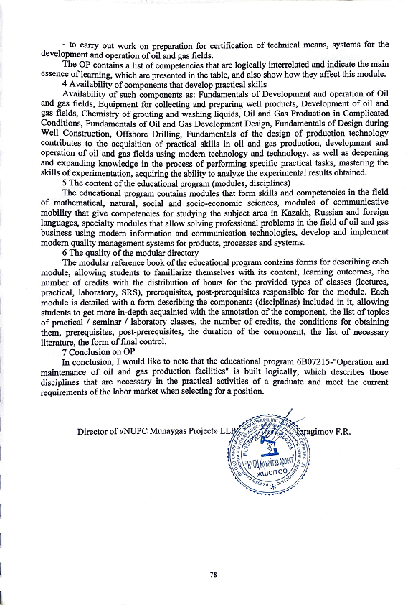
REVIEW
6B07215-"Operation and maintenance of oil and gas production and processing facilities",
developed at the M. Auezov State Technical University, Shymkent

1 A brief description of the company and the profile of its activities.
Oil and gas production facilities are operated in rather difficult climatic conditions, the oil from Kazakhstan's fields is mainly paraffin, highly viscous with a high content of hydrogen sulfide in western fields. This circumstance increases the demand for the training of highly qualified personnel for this industry. In this regard, the Bachelor of Engineering and Technology specialty in the educational program 6B07215 – Operation and maintenance of oil and gas production facilities is currently very attractive. Future young professionals are attracted by relatively high wages. In this industry, specialists always have a chance to show their abilities, the latest developments are constantly being introduced here. Since 2016, there has been a need to open the specialty 6B07215 – Operation and maintenance of oil and gas production facilities at the M.Auezov South Ural State University.
After a comprehensive training, a graduate of the direction «Operation and maintenance of oil and gas production facilities» will have sufficient qualifications to work in the industry on technological processes for servicing oil and gas production facilities. This is facilitated by the skills that young people acquire in the learning process.
2 Relevance and relevance of the OP.
The relevance of the program is due to the need to train qualified, competitive specialists in the field of operation and maintenance of oil and gas production facilities, who are able to perform technical solutions and implement strategic programs for the development of strategy in the oil and gas industry of the Republic of Kazakhstan.
The educational program is in demand in modern conditions of increasing the volume of hydrocarbon production. The demand for OP is due to the need to increase the competitiveness of domestic specialists in the labor market, who must possess a set of necessary knowledge and skills that can evaluate information, set and solve scientific and practical tasks. These trends show the importance of OP for the training of competitive specialists in higher educational institutions of our country.
3 Learning outcomes and competencies, their relationship to the demands of the labor market
The educational program contains the results of training and competencies, namely: be able to solve the problems of operation and maintenance of oil and gas production facilities using modern methods; be ready to acquire new knowledge and technologies in the professional field, set goals and formulate tasks related to the implementation of professional functions; justify the choice of technological schemes and design equipment for the oil and gas industry;
The results of training and competencies are closely related to the demands of the labor market, since the external examination and review of the OP goes through employers who study the OP comprehensively, on the basis of this and give a review of the educational program before the approval of the program.
4 Availability of components that develop practical skills
The content of the OP is aimed at preparing intellectual capital that meets the needs of the individual and society, based on the principles of "education throughout life" and self-education, mobility, development of creative thinking and competence approach.
This educational program includes components that form professional competencies, develop practical skills through the study of disciplines: The content of this OP is aimed at training intellectual personnel who would satisfy the needs of the individual and society based on the principles of "education throughout life" and self-education, mobility, development of creative thinking and scientific approach. This educational program includes components that form professional competencies, develop practical skills by studying the following disciplines: Fundamentals of oil and gas business; Technology and technology of oil production;
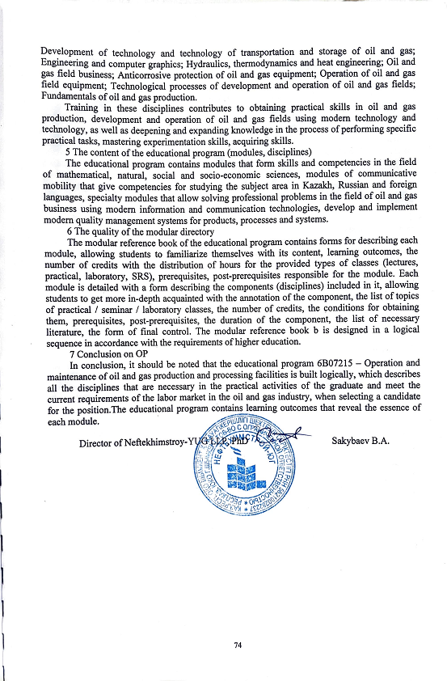

REVIEW
6B07215-"Operation and maintenance of oil and gas production and processing facilities",
developed at the M. Auezov South, Shymkent

1 A brief description of the company and the profile of its activities.
Bachelor's degree training at the M.Auezov UCU under the educational program 6B07215- "Operation and maintenance of oil and gas production facilities" has been carried out since 2017. According to this program, specialists are trained in the field of oil and gas well development, production, preparation and transportation of oil and gas. Graduates of this profile are in demand in the oil industry all over the world. Technical training opens up broad career prospects for graduates. After graduating from the university, graduates can start their work as an oil and gas production operator, a well maintenance and overhaul operator, a process engineer, a specialist in oil and gas production at the fields of the Republic of Kazakhstan. It is also possible to enroll in a master's degree, and then, if you wish, continue your studies in graduate school and find your place in the field of education or in research institutes.
2 Relevance and relevance of the OP.
The relevance of the OP is connected with the need to train qualified bachelors in the field of operation and maintenance of oil and gas production facilities to fulfill strategically important tasks for the industrial development of the Republic of Kazakhstan. The program is focused on the practical application of acquired knowledge, skills and abilities to solve real scientific, technical and production tasks facing the country's oil and gas companies
OP "Operation and maintenance of oil and gas production facilities" is a comprehensive system of educational and methodological documents reflecting the purpose, objectives, content of the educational process, expected results, assessment of the quality of graduate training, taking into account the needs of the labor market. Consequently, mastering the OP and successful final certification will allow the graduate to obtain a bachelor's degree in the operation and maintenance of oil and gas production facilities.
3 Learning outcomes and competencies, their relationship to the demands of the labor market
The results of the training program are achieved through the following training activities:classroom classes: lectures, seminars, practical and laboratory classes are conducted taking into account innovative teaching technologies, the use of the latest achievements of science, technology and information systems; extracurricular classes: independent work of the student, including under the guidance of a teacher, individual consultations; conducting professional practices, completing term papers and theses (projects). The educational program contains learning outcomes and competencies, namely:
- participate in the development of structures of production, technological, service and operational units for oil, gas and condensate production;
- to carry out a comprehensive analysis of the state of development (development projects) of oil and gas fields (technical and economic, resource and energy, environmental analyses) according to the latest methods;
- be able to solve problems related to the development and operation of oil and gas fields using modern production methods;
- perform work on preparation for certification of technical means, systems for the development and operation of oil and gas fields.
Students will receive competencies in the field of:
- choosing a rational way of operating oil and gas wells, taking into account energy-efficient technologies;
- reasonable choice of technology and techniques for underground repair and construction of oil and gas wells;
- determination of the technical and economic efficiency of the development and operation of oil and gas fields on land and at sea;
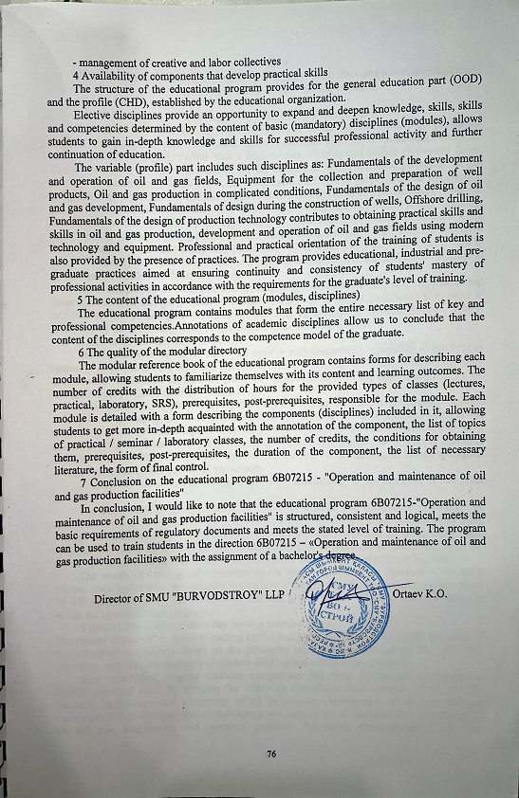

REVIEW
6B07215-"Operation and maintenance of oil and gas production and processing facilities",
developed at the M. Auezov South, Shymkent

1 A brief description of the company and the profile of its activities.
Currently, more than 200 fields are in operation in our republic, where oil production facilities are operated in rather difficult climatic conditions. The oils of Kazakhstan's fields are mainly paraffinous, highly viscous with a high content of hydrogen sulfide in western fields. This circumstance increases the demand for the training of highly qualified personnel for this industry. In connection with the above, the specialty of the Department of Electrical Engineering and technology under the educational program 6B07215–Operation and maintenance of oil and gas production facilities is currently very attractive for young students. Future young specialists are attracted to this specialty by the opportunity to work with joint foreign companies in the future. In this specialty, young people always have a chance to show their abilities, the latest developments are constantly being introduced here. Thus, since 2016, there has been a need to open the specialty 6B07215 – Operation and maintenance of oil and gas production facilities at the M.Auezov South Ural State University.
Upon completion of education and training, a graduate of the direction "Operation and maintenance of oil and gas production facilities" will have sufficient qualifications to work in this industry on technological processes for servicing oil and gas production facilities. This is facilitated by the skills that young people acquire in the learning process.
2 Relevance and relevance of the OP.
The relevance of the OP is due to the need to train competitive specialists in the field of operation and maintenance of oil and gas production facilities, who are able to perform technical solutions and implement strategic programs for the development of the state strategy in the oil and gas industry of the Republic of Kazakhstan.
In the conditions of increasing oil prices, this educational program is in demand in modern conditions of increasing the volume of hydrocarbon production. OP is in demand, which is due to the need to increase the competitiveness of domestic specialists in the labor market, who must possess a set of necessary knowledge and skills, evaluate information, set and solve scientific and practical tasks. These trends show the importance of OP for the training of trained specialists in higher educational institutions of our country.
3 Learning outcomes and competencies, their relationship to the demands of the labor market
The educational program contains the results of training and competencies, namely: be able to solve the problems of operation and maintenance of oil and gas production facilities using modern methods; be ready to acquire new knowledge and technologies in the professional field, set goals and formulate tasks related to the implementation of professional functions; justify the choice of technological schemes and design equipment for oil and gas production facilities.
The results of training and competencies are closely related to the demands of the labor market, since the external examination and review of the OP goes through employers who study the OP comprehensively, on the basis of this and give a review of the educational program before the approval of the program.
4 Availability of components that develop practical skills
The content of this OP is aimed at training intellectual personnel who would satisfy the needs of the individual and society based on the principles of "education throughout life" and self-education, mobility, development of creative thinking and competence approach.
This educational program includes components that form professional competencies, develop practical skills by studying the following disciplines: Fundamentals of oil and gas business; Technology and technology of oil production; Development of oil, gas and gas condensate fields; Development of technology and technology of transportation and storage of oil and gas; Engineering and computer graphics; Hydraulics, thermodynamics and heat
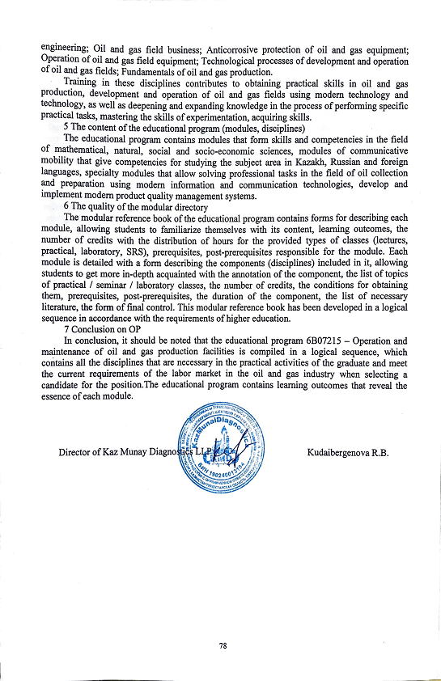

REVIEW
6B07215-"Operation and maintenance of oil and gas production and processing facilities",
developed at the M. Auezov South, Shymkent

1 A brief description of the company and the profile of its activities.
The oil and gas industry is one of the most important for Kazakhstan, therefore, great attention is paid to the training of personnel for the oil and gas sector, professional development. Many oil companies are currently experiencing a shortage of national engineering and technical personnel. The demand for top-level specialists in the labor market is due to the fact that it is necessary to extract oil and gas in increasingly complex mining and geological conditions.
Bachelor's degree training at the M.Auezov UCU under the educational program 6B07215- "Operation and maintenance of oil and gas production facilities" has been carried out since 2017.
2 Relevance and relevance of the OP.
The relevance of the OP is connected with the need to uChDate and prepare personnel reserves in the field of operation and maintenance of oil and gas production facilities to fulfill strategically important tasks of the industry.
The program is focused on the practical application of acquired knowledge, skills and abilities to solve real scientific, technical and production tasks facing the country's oil and gas companies. The training program for specialists in this area corresponds to the modern realities of the labor market, the requirements of existing organizations and enterprises.
3 Learning outcomes and competencies, their relationship to the demands of the labor market
The educational program contains a decomposition of learning outcomes (P1-P12) and competencies, namely:
РО 1 Communicate freely in the professional environment and society in Kazakh, Russian and English.
РО 2 Demonstrate natural science, mathematical, social, socio-economic and engineering knowledge in professional activity, methods of mathematical data processing, theoretical and experimental research, regulatory documents and elements of economic analysis.
РО 3 Possess information and computational literacy, the ability to generalize, analyze and perceive information, set goals and choose ways to achieve.
РО 4 He is able to solve problems related to the development and operation of oil and gas fields using modern production methods.
РО 5 Participates in the development of the structures of production and technological, service and operational units for the extraction of oil, gas and condensate.
РО 6 He is able to organize and control the performance of the main types of routine maintenance work on the operation, overhaul of wells using modern achievements of science and technology.
РО 7 He is able to conduct a comprehensive analysis of the state of development (development projects) of oil and gas fields (technical and economic, resource and energy, environmental analyses) according to the latest methods.
РО 8 Possess knowledge on the choice of technological schemes and design equipment for the oil and gas industry.
РО 9 Master the methods of technological, mechanical and hydraulic calculations of equipment for the collection and preparation of well products.
РО 10 To be used for sampling and systematization of data of technical supervision of the operation of equipment used in the development and operation of oil and gas wells.
РО 11 To use research, entrepreneurial skills and skills of working in conditions of uncertainty.
РО 12 To work effectively individually and as a team member, to correctly stand up your point of view, adjust your actions and use various methods.
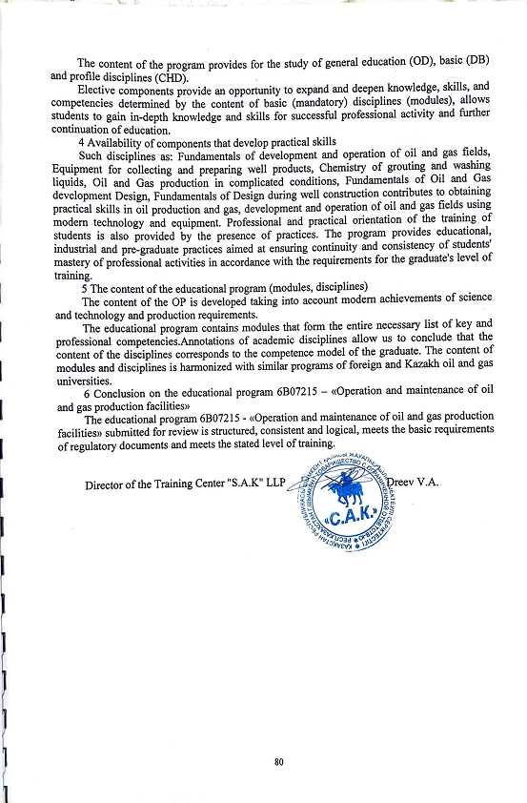

Appendix 2

Expert opinion
for the educational program
6B07215- «Operation and maintenance of oil and gas production facilities»
1. The relevance of the OP. An optional parameter of the Bologna process is a modular training system, which is of great importance in planning and organizing the educational process, taking into account the interests of employers and the needs of society.
The modular system and the intensification of the information and activity learning process associated with its introduction, the system of knowledge control and professional aptitude will lead to an increase in the efficiency and quality of training specialists, ensuring the purposefulness of creative activity of the individual. In this regard, the development of the educational program 6B07215 – «Operation and maintenance of oil and gas production facilities» is an urgent task.
2. Compliance with the OP formulated goals consistent with the mission of the university, the requests of employers and students. The educational program 6B07215 - "Operation and maintenance of oil and gas production facilities" corresponds to the goals agreed with the mission of the university, the requests of employers and students. This is confirmed by the training of specialists who possess theoretical and practical knowledge in the field of development and operation of oil and gas fields, who possess methods and tools for assessing and analyzing the current state of production development, as well as able to apply the acquired knowledge and skills to effectively solve production problems.
3. Compliance with the National Qualifications Framework of the Republic of Kazakhstan. The National Qualifications Framework, along with industry frameworks and professional standards, is part of the National Qualifications System. On its basis, the sectoral framework of qualifications in the fields of education and science, labor, and agriculture has been developed. The National Qualifications Framework in Kazakhstan has been developed and approved by the protocol of the RTK dated 16.03.2016. The national qualification framework is the harmonization of the national education system with the European one. The educational program 6B07215 - "Operation and maintenance of oil and gas production facilities" corresponds to the industry qualification framework of the oil and gas, oil refining and petrochemical industries (Protocol No. 2 of December 27, 2016), professional standards have been uChDated.
4. Reflection in the OP of learning outcomes and competencies based on Dublin descriptors embedded in professional standards/industry frameworks. Learning outcomes and competencies are reflected in accordance with the Dublin Descriptors, Cycle 1 of the Qualification Framework of the European Higher Education Area (AFrameworkforQualificationsoftheEuropeanHigherEducationArea), as well as level 6 of the European Qualification Framework for Lifelong Education. According to the Dublin descriptors, the general competencies of a university graduate are formed on the basis of requirements for general education, socio-ethical competencies, economic and organizational and managerial competencies, and special competencies.
5. Compliance with SSO. The educational program "Operation and maintenance of oil and gas production facilities" was developed in accordance with the State Standard of Higher Education approved by the Decree of the Government of the Republic of Kazakhstan dated August 23, 2012 No. 1080 with amendments and additions dated May 13, 2016 No. 292, the standard curriculum of the specialty 5B070800- Oil and Gas business approved by the Order of the Ministry of Education and Science of the Republic of Kazakhstan No. 425 dated 05.07.2016, professional standard/industry qualification framework.
6. Structure and content of the OP, application of the modular construction principle. The educational program contains general and interdisciplinary modules, including the basics of engineering and technical sciences, chemical engineering, and vocational training. Each module of the educational program is focused on achieving a certain learning outcome, that is, competence.
7. The presence of components in the OP for training for professional activity, developing key competencies, intellectual and academic skills that reflect the changing requirements of society, including the implementation of the presidential program for mastering three languages: Kazakh, Russian and English. The educational program 6B07215 - "Operation and maintenance of oil and gas production facilities" was developed in the context of the competence model of training specialists. At the same time, competencies are divided into core and professional competencies. Competencies include knowledge and understanding (theoretical knowledge of the academic field, the ability to know and understand), knowledge of how to act (practical and operational application of knowledge and skills to specific situations) and knowledge of how to be (value aspect as an integral part of living with others in a social context).
Russian Russian As part of the implementation of the Presidential program on multilingualism, i.e. mastering three languages (Kazakh, Russian and English), a module of communicative mobility is provided, including such disciplines as Professional Kazakh (Russian) language and Professionally-oriented foreign language.
8. The logical sequence of disciplines and the reflection of the basic requirements in the curricula and training programs. In the educational program 6B07215 - "Operation and maintenance of oil and gas production facilities", the logical sequence of studying disciplines is clearly traced, which is reflected in the table "Content of the educational program". The modules of the educational program are logically interrelated components of the training program in specific areas or disciplines.
9. Reflection in the OP of the system of accounting for the academic load of students and teachers in loans, its compliance with the parameters of the credit system of education. In the educational program 6B07215 - "Operation and maintenance of oil and gas production facilities", the system of accounting for the academic load of students and teachers in credits is studied in a summary table reflecting the volume of loans mastered in the context of the modules of the educational program.
The volume of one module is 3 or more Kazakhstani credits or and includes two or more academic disciplines.
10. The presence in the programs of industrial practice to consolidate the theoretical material expressed in the academic load in credits. The educational program provides industrial practice in the 2nd and 3rd courses, which are included in the corresponding module of the educational program. The purpose of the production practice is to obtain practical and consolidate theoretical knowledge on 6B07215 - "Operation and maintenance of oil and gas production facilities" in the field of development and operation of oil and gas fields, equipment used, as well as safety and environmental protection measures.
11. Information about the teaching staff involved in the implementation of the OP. In the educational program 6B07215 - "Operation and maintenance of oil and gas production facilities", information about the teaching staff involved in the implementation of the OP is presented in the form of a modular reference book. The modular reference book is a necessary component of the credit technology of training, which ensures the electability of the teacher and the learning trajectory. The modular reference book contains data on the teacher, on the distribution of credits, types of classes, the level of the module, the number of credits, the form of training, the prerequisites and post-prerequisites of the module, the content of the module, the results of training, the form of final control.
12. Qualifications obtained as a result of mastering the OP. Students who have successfully passed the final certification for the development of the educational program 6B07215 – «Operation and maintenance of oil and gas production facilities» are awarded the degree «Bachelor of Engineering and Technology in the educational program» 6B07215 – «Operation and maintenance of oil and gas production facilities».
13. Рекомендация. The above shows that the educational program 6B07215 - "Operation 